**GAAM Migration from IE 11 to Google Chrome**

This article will review the process of migrating GAAM from Internet Explorer 11 to Google Chrome, assuming GAAM with IE is already configured and running in your environment. Note, this article is only applicable for GAAM running Citrix Virtual Apps and Desktops or Microsoft RDS launches.

**Article Contents**

Please follow the steps outlined in all 4 sections below, in order.

1. [Migration Prerequisites](https://support.goliathtechnologies.com/hc/en-us/articles/6737280161559-GAAM-Migration-from-IE-11-to-Google-Chrome#h_01G63WX8605PZR1C4H4B7GXP99)
2. [Launch Endpoint Migration](https://support.goliathtechnologies.com/hc/en-us/articles/6737280161559-GAAM-Migration-from-IE-11-to-Google-Chrome#h_01G63WZ69FBMWD6H9G1A798XXG)
   1. [Migration via Goliath Console](https://support.goliathtechnologies.com/hc/en-us/articles/6737280161559-GAAM-Migration-from-IE-11-to-Google-Chrome#h_01G63WZE5YN7EMA9SS2135BGNG)
   2. [Migration via GAAMEndpoint.exe](https://support.goliathtechnologies.com/hc/en-us/articles/6737280161559-GAAM-Migration-from-IE-11-to-Google-Chrome#h_01G6JX6V5JTGN735XPD9R907N7)
   3. [Manual Migration](https://support.goliathtechnologies.com/hc/en-us/articles/6737280161559-GAAM-Migration-from-IE-11-to-Google-Chrome#h_01G6JX74PQMDQ59PRJHQ3B9AY0)
3. [Launch Endpoint Preparation](https://support.goliathtechnologies.com/hc/en-us/articles/6737280161559-GAAM-Migration-from-IE-11-to-Google-Chrome#h_01G63X0VFDMC9JGY5BNV7VCVN1)
4. [Google Chrome Enablement](https://support.goliathtechnologies.com/hc/en-us/articles/6737280161559-GAAM-Migration-from-IE-11-to-Google-Chrome#h_01G63X6R837WJ32BTXGD7TDAMT)

**Migration Prerequisites**

This section reviews the items required before proceeding with the GAAM Migration from IE 11 to Google Chrome. Once all items have been met please follow the steps in [Launch Endpoint Migration](https://support.goliathtechnologies.com/hc/en-us/articles/6737280161559-GAAM-Migration-from-IE-11-to-Google-Chrome#h_01G63WZ69FBMWD6H9G1A798XXG) to start the migration process.

* Goliath Server Prereqs:
  + Must be running v12.0.1 or newer
* Launch Endpoint Prereqs:
  + Must be currently launching sessions via Internet Explorer 11
    - Please reference [Launch Endpoint Installation & Configuration](https://support.goliathtechnologies.com/hc/en-us/articles/360024769993) for net new install steps
  + Google Chrome is installed
  + Powershell v5 or newer is installed

**Launch Endpoint Migration**

Please reference one of the 3 sections below for steps to migrate your GAAM Launch Endpoint(s) from IE 11 to Google Chrome. **Note, it is recommended to suspend your scheduled GAAM launches while completing this section, and subsequent sections in this article.** You will be directed when it is time to resume them.

**Migration via Goliath Console**

Please follow the below steps to migrate your GAAM Launch Endpoint from using IE 11 to Google Chrome. **Note, if your Goliath Server is also configured as you GAAM Launch Endpoint do not follow the steps in this section.** Please use the steps in the **Automated Migration via GAAM Endpoint.exe** or **Manual Migration** sections below instead.

1. Connect to the Goliath web console
2. Follow the steps in the article [Agent Installation/Update via the Goliath Console](https://support.goliathtechnologies.com/hc/en-us/articles/360025093394) to upgrade the agent on your GAAM Launch Endpoint(s)
   1. If your launch endpoint is also the Goliath Server, please skip this step

Now that this section has been completed, please continue the migration by following the steps in the [Launch Endpoint Preparation](https://support.goliathtechnologies.com/hc/en-us/articles/6737280161559-GAAM-Migration-from-IE-11-to-Google-Chrome#h_01G63X0VFDMC9JGY5BNV7VCVN1) section.

**Migration via GAAMEndpoint.exe**

Please follow the below steps to migrate your GAAM Launch Endpoint from using IE 11 to Google Chrome. The below steps are applicable for both remote endpoints or if the Goliath Server is configured as the GAAM Launch Endpoint.

1. On the Goliath Server, navigate to the **Bin** folder within the install directory.
   1. The default locations is either **C:\Program Files (x86)\MonitorIT\Bin**
2. Locate the **GAAMEndpoint**executable
   1. If the launches will be executing locally on the Goliath Server, launch the executable as the Windows Service Account configured to run GAAM
   2. If the launches will be executing on a remote machine:
      1. Log into the machine as the Windows Service Account created for GAAM
      2. Copy over the **GAAMEndpoint**executable and launch it
3. The executable will start the install process and display a Welcome screen, click **Next** to proceed.
   1. 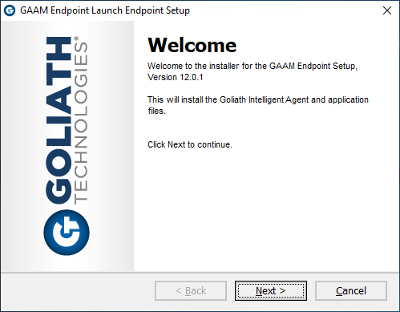
4. The installer will prompt for the launch type, Citrix XenApp & XenDesktop is selected by default, choose the option for the virtualization environment that will be tested and then click **Next** to proceed. For Cerner Patient Portal please choose the option for **Other**.
   1. 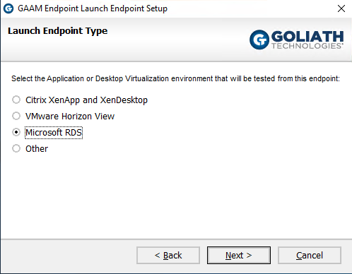
5. If the **launch endpoint is the Goliath Server, proceed to step 7**. If the launch endpoint is a remote machine, enter the **IP Address** or **DNS Name** for the Goliath Server (or Master Agent if applicable) and the port used for agent communication (default is 443)
   1. 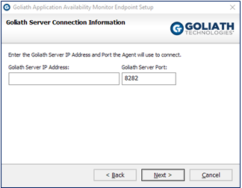
6. If the **launch endpoint is the Goliath Server, proceed to step 7**. If the launch endpoint is a remote machine, you will next be prompted to verify the install directory of the technology.
   1. 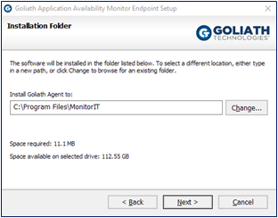
7. Next, choose if to disable UAC at the system level via the installer. **Please note, a reboot is required in order for the change to take place. Also, if UAC is not disabled the technology will no function and the configuration will be incomplete.**
   1. 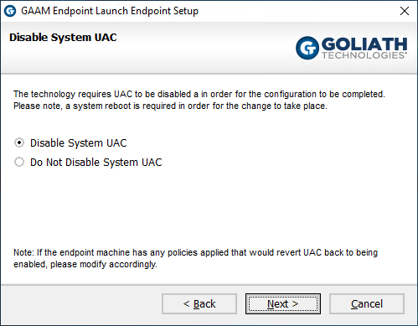
8. Verify that the following installation settings are correct, if so select **Next** to proceed with the installation or **Back** to make the appropriate modifications.
   1. 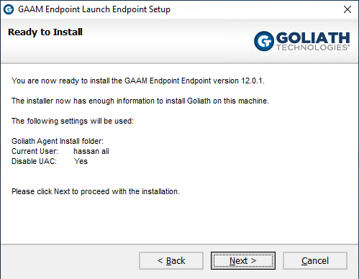
9. During the installation process, a progress bar will show the progress of installing the Launch Endpoint, as seen in the figure below.
   1. 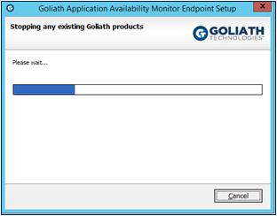
10. Once the Launch Endpoint is successfully installed the install program will display a message that the installation is complete. Click **Finish** to exit the install program.

Now that this section has been completed, please continue the migration by following the steps in the [Launch Endpoint Preparation](https://support.goliathtechnologies.com/hc/en-us/articles/6737280161559-GAAM-Migration-from-IE-11-to-Google-Chrome#h_01G63X0VFDMC9JGY5BNV7VCVN1) section.

**Manual Migration**

Please follow the below steps to migrate your GAAM Launch Endpoint from using IE 11 to Google Chrome. The below steps are applicable for both remote endpoints or if the Goliath Server is configured as the GAAM Launch Endpoint.

1. RDP to the Goliath Server
2. Open Windows Files Explorer and navigate to the **Bin** folder within the install directory.
   1. The default locations is **C:\Program Files (x86)\MonitorIT\Bin**
3. Copy **InstallBrowserDriver.ps1** from the **Bin** folder to the install directory on the GAAM launch endpoint.
   1. If your launch endpoint is remote, the default location is **C:\Program Files\MonitorIT**
   2. If your launch endpoint is also the Goliath Server, the default location is **C:\Program Files (x86)\MonitorIT**
4. If your GAAM Launch Endpoint is not the Goliath Server, upgrade the Goliath Agent using one of the upgrade options below. If it is, please skip this step.
   1. [Agent Installation/Update via Installer](https://support.goliathtechnologies.com/hc/en-us/articles/360025959993)
   2. [Agent Installation/Update via Command Line](https://support.goliathtechnologies.com/hc/en-us/articles/360025008894)
   3. [Agent Installation/Update via the Goliath Console](https://support.goliathtechnologies.com/hc/en-us/articles/360025093394)

Now that this section has been completed, please continue the migration by following the steps in the [Launch Endpoint Preparation](https://support.goliathtechnologies.com/hc/en-us/articles/6737280161559-GAAM-Migration-from-IE-11-to-Google-Chrome#h_01G63X0VFDMC9JGY5BNV7VCVN1) section.

**Launch Endpoint Preparation**

Citrix Virtual Apps and Desktop or Microsoft RDS launches are executing Google Chrome under the profile of the windows account that is running the LogonSimulator.exe process. To ensure that the GAAM launches are successful, you'll want to first manually bypass any unexpected Chrome prompts.

For example, with Citrix deployments you'll want to repeat the following steps for each URL being tested:

1. Launch Google Chrome and navigate to the Storefront or NetScaler Gateway URL. Note if you see any of the following items as they'll be needed in the next section.
   1. Note if there is a "Detect Receiver" button that must be clicked before you are able to authenticate
   2. Note if there is a company issued EULA prompt hat must be clicked before you are able to authenticate
   3. If there is a "Open Citrix Receiver Launcher?" or "Open Citrix Workspace Launcher?" be sure to check the box for "Always Allow ....." before accepting
      1. 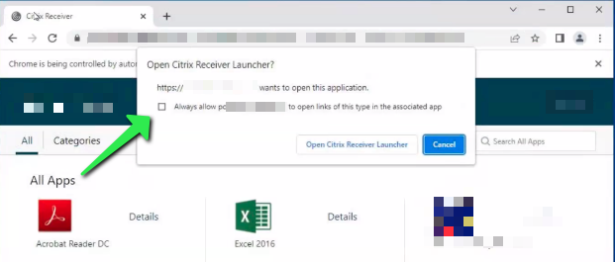
2. Authenticate to the Citrix Environment. Note if you see any of the following items as they'll be needed in the next section.
   1. Note if there is a "Detect Receiver" button that must be clicked before you are able to reach the storefront page
   2. Note if there is a company issued EULA prompt hat must be clicked before you are able to reach the storefront page
3. Click on an application or desktop to launch it. If the .ica files appears in the downloads bar at the bottom of the screen, click on the arrow and be sure to select **Always open files of this type**
   1. 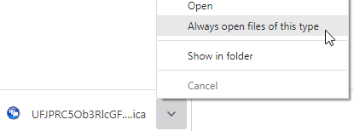

Once all of your URL(s) have been configured for the prompts to be bypassed, please proceed to the next section.

**Google Chrome Enablement**

1. RDP to the Goliath Server
2. Open Windows Services and Stop the **MonitorIT Server Service**
3. Open Windows Files Explorer and navigate to the **Bin** folder within the install directory.
   1. The default locations is **C:\Program Files (x86)\MonitorIT\Bin**
4. Edit the**GPMServer.cfg** file and update the line **"GAAMSeleniumEnabled"** from **false** to **true** and save the file
   1. Note, if you run into permission issues, the file can be saved onto the Desktop and then copy/paste it back into the Bin folder. If this occurs, please ensure the saved file is cfg and not txt.
   2. 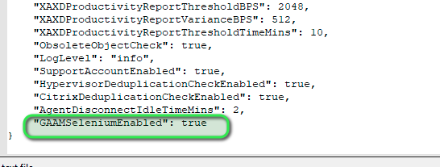
5. Start the **MonitorIT Server Service**
6. If necessary, edit the GAAM schedules for Citrix to enable the Detect Receiver prompt
7. Resume your GAAM schedules

The migration has now been completed and the new GAAM launches should now run Google Chrome instead of Internet Explorer 11. If you run into any issues please don't hesitate to create a support ticket.